Project Title: LumenTrace

1. Abstract:
LumenTrace is a computational project designed to determine the local time a historical photograph was taken by analyzing the geometry of shadows. The methodology involves a multi-stage image processing pipeline to restore the input photograph, isolate shadow regions, and perform geometric analysis to calculate the sun's azimuth and elevation angles. These parameters, combined with the known date and location of the photograph, are fed into a solar position algorithm to solve for the time of day. The project culminates in a 3D visualization of the scene, reconstructing the sun-object-shadow relationship, thereby transforming archival images into forensic sundials.

2. Proposed Methodology
The project is structured into a five-phase pipeline:
- Image Restoration: The input photograph is first restored. This involves applying histogram equalization for contrast, frequency domain filtering to remove periodic noise, and convolutional smoothing to reduce grain.
- Shadow Segmentation: The restored image is processed with adaptive thresholding to accurately isolate all shadow areas, creating a binary shadow mask.
- Geometric Analysis: The angle of a prominent shadow is determined using two complementary methods for robustness:
  - Method A (Edge-Based): Edges are detected, and the Hough Transform is applied to find the angle of the shadow's primary line.
  - Method B (Region-Based): The shadow mask is analyzed to find a distinct shadow "blob," and its region descriptors (specifically orientation) are calculated to find its angle.
- Sun Elevation Calculation: An object-shadow pair is identified. The ratio of the object's height to its shadow's length (in pixels) is used with the arctangent function to calculate the sun's elevation angle.
- Time Estimation & Visualization: The calculated solar azimuth (from the shadow angle) and elevation, along with the known date and location, are used in a solar position algorithm to solve for the local time. The result is then visualized in a 3D scene.

3. Process Flowchart:
Start

End
Input Image

Phase 1: Image Restoration

Output: Estimated Time
Output: 3D Visualization Scene

Use solar position algorithm
Contrast and noise removal
Phase 5: Time Estimation
Phase 2: Shadow Segmentation

Object/shadow ratio
Create shadow mask
Phase 4: Calculate Sun Elevation
Phase 3: Geometric Analysis

Method B: Region Descriptors on Shadow Blob
Method A: Edge Detection + Hough Transform

Calculate Shadow Angle
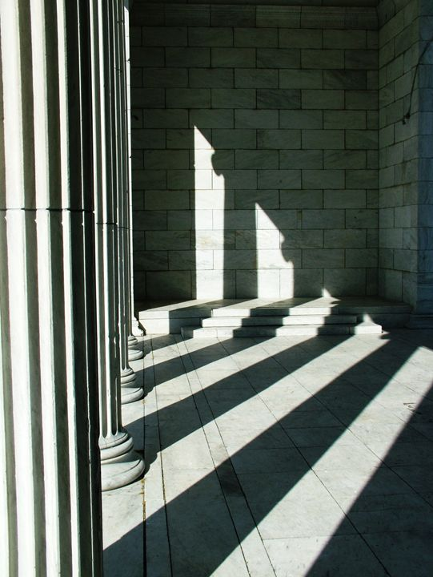
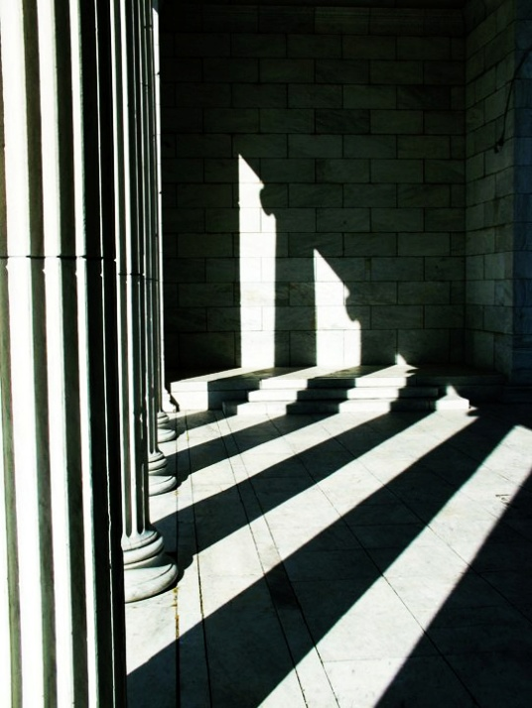
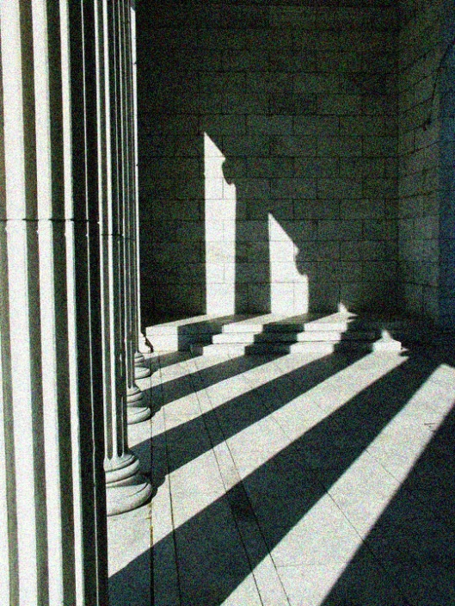
4. Probable Output:
Fig 3: High Contrast Image
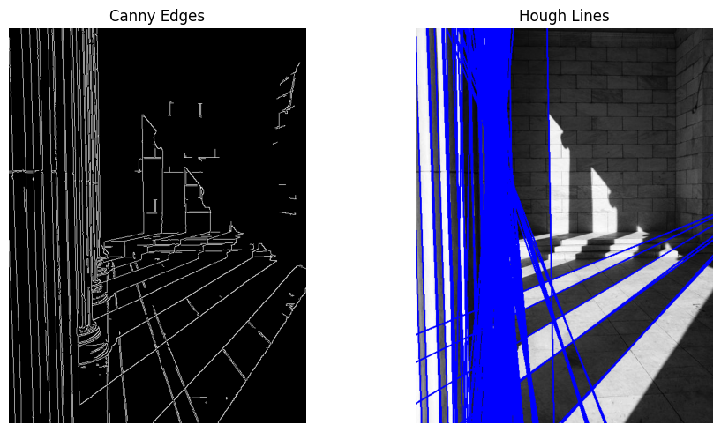
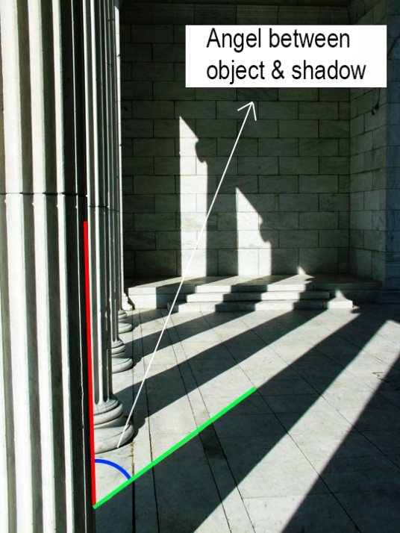
Fig 4: Edge & Line Detection
Fig 5: Theta Calculation
Fig 2: Smooth Image
Fig 1: Noisy Image

Final Output: Estimated Time- 5:40pm
4. Topics and Techniques Utilized:
- Histogram Equalization: Used in the initial preprocessing stage to enhance the contrast of faded grayscale images, making shadow boundaries more distinct.
- Frequency Domain Filtering: Employed to remove periodic noise (e.g., paper texture, scan lines) by identifying and suppressing specific frequencies in the image's Fourier spectrum.
- Convolution: Applied for two purposes: 1) using Gaussian or median filters to reduce random noise and film grain, and 2) using Sobel or Canny operators for edge detection, which is fundamental to the Hough Transform.
- Segmentation (Adaptive Thresholding): Used to create a precise binary mask of shadow regions, effectively separating them from sunlit areas even under non-uniform lighting conditions.
  - Region Descriptors: After segmenting a shadow, its properties are calculated. Specifically, the orientation descriptor is used to determine the shadow's angle by analyzing its principal axis, offering a robust alternative to line-based methods.
  - Hough Transform: A key technique used on the edge-detected image to identify dominant straight lines, providing a method to measure the shadow's angle.
  - 3D Visualization: Utilized to create an intuitive 3D reconstruction of the scene, showing the object, the ground plane, the projected shadow, and the calculated position of the sun.

5. References:
- Gonzalez, R. C., & Woods, R. E. (2018). Digital Image Processing (4th ed.). Pearson.
- Hough, P. V. C. (1962). Method and means for recognizing complex patterns. U.S. Patent 3,069,654.
- OpenCV (Open Source Computer Vision Library): For implementation of core image processing functions.
- Pysolar, Pvliv Library: For implementation of solar position algorithms.

